# ASS-1.4

# Task Description #1

Q) Open google colab and use google gemini to generate python code that performs sorting of a list using both the bubble sort algo and pythons build in sort function

# Promp-1: Generate a python code for sort using bubble sort algo and sort function

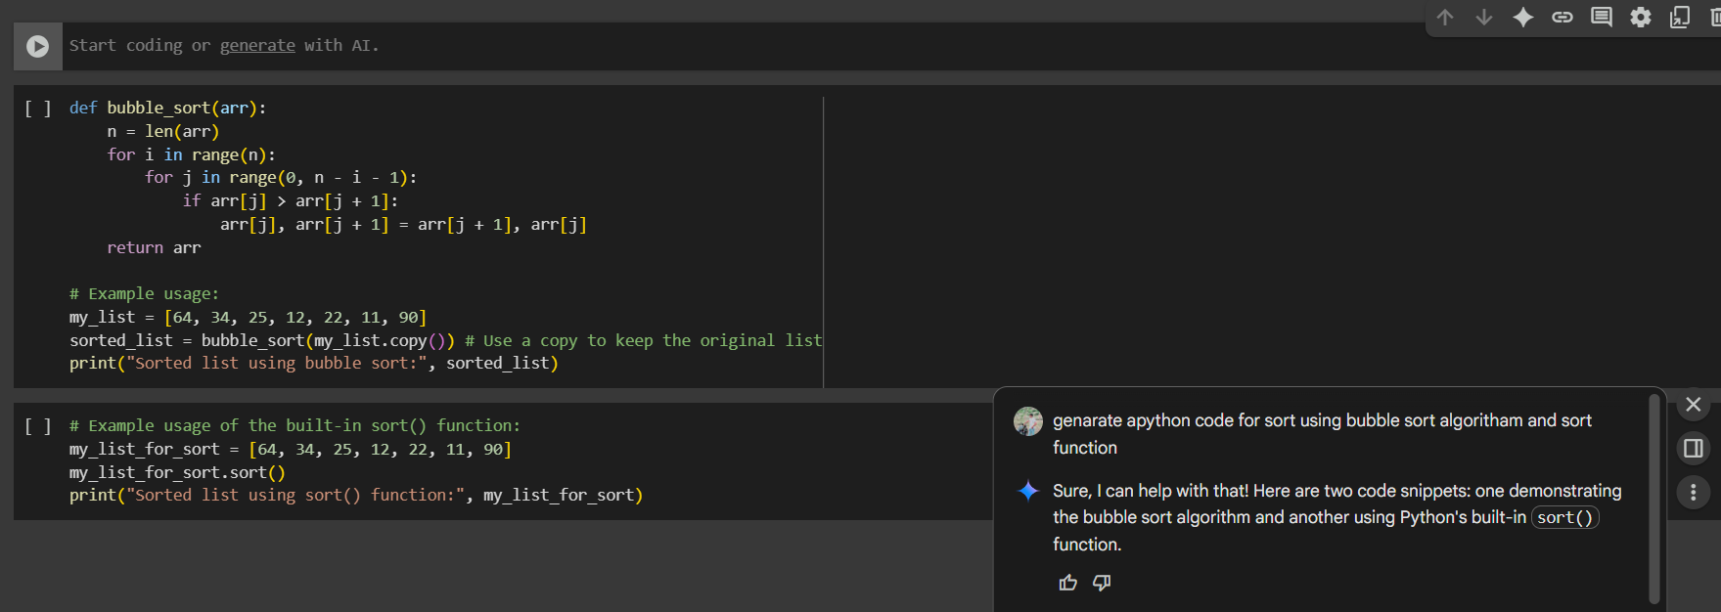

#Prompt-2: Compare bubble sort algo and in build sort function.

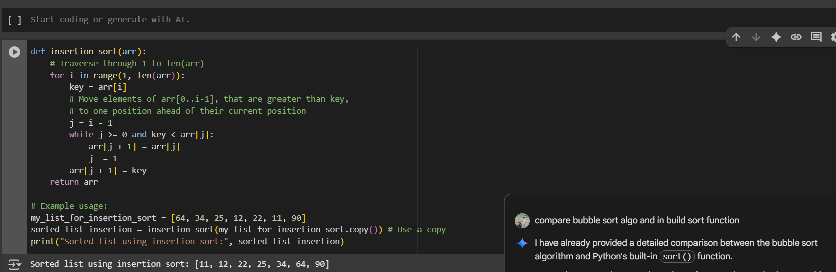

OUTPUT:



# Task Description #2

Q) In Colab, use Google gemini to generate a python function that takes a string and returns, the number of vowels, the number of consonants, the number of digits in the string

#Prompt-1: Generate a python function that takes a string and returns, the number of vowels, the number of consonants, the number of digits in the string

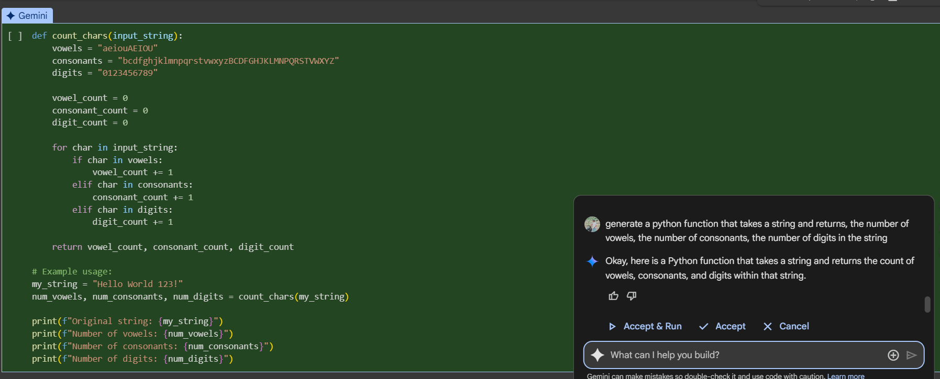

#Prompt-2: return the number of vowels, consonants, digits in the given string.

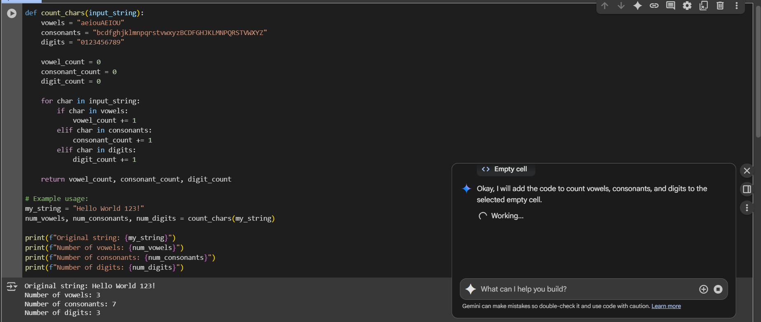

OUTPUT:

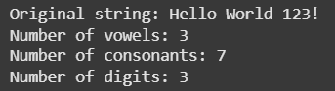

# TASK DESCRIPTION #3

Q) Use Gemini to generate a python program that performs file handling

Create a text file

Write sample text

Read and display the content

#Prompt-1: A python program that performs file handling Create a text file Write sample text Read and display the content

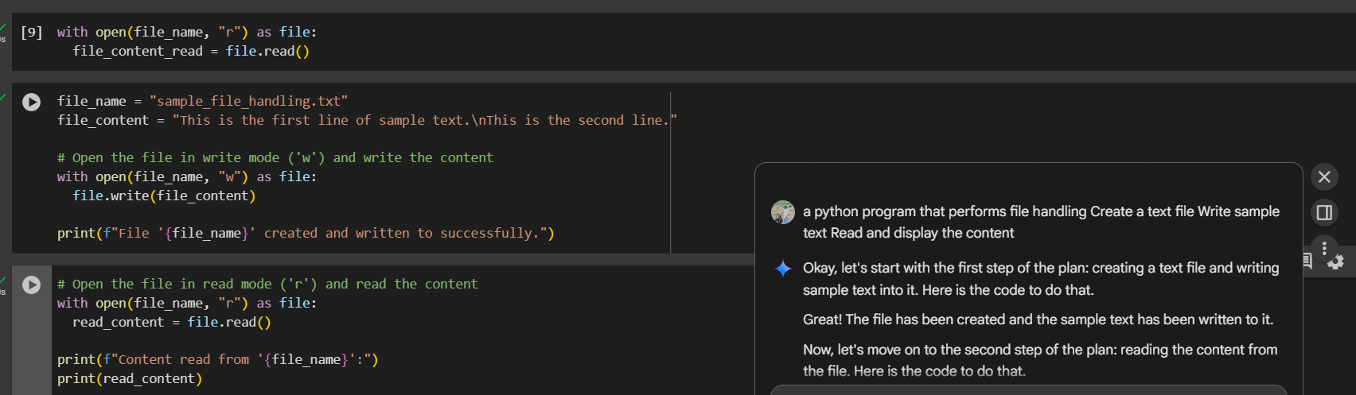

OUTPUT:

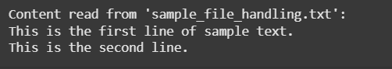

# Task Description #4

Q) Ask google gemini to generate a python program that implements a simple calculator using functions (add, subtract, multiply, divide). That ask gemini to explain how the code works.

#Prompt-1: a simple calculator using functions (add, subtract, multiply, divide). explain how it works

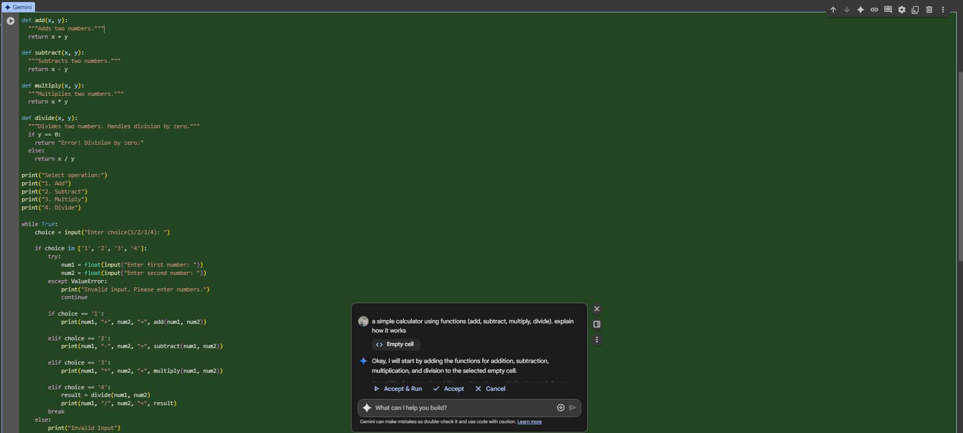

OUTPUT:

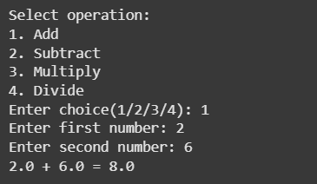

# Task Description #5

Q) Use gemini to create the python program that checks if a given year is a leap year or not . try different prompt styles and see how gemini modifies its code suggestions

#Prompt-1: check if a given year is a leap year or not.

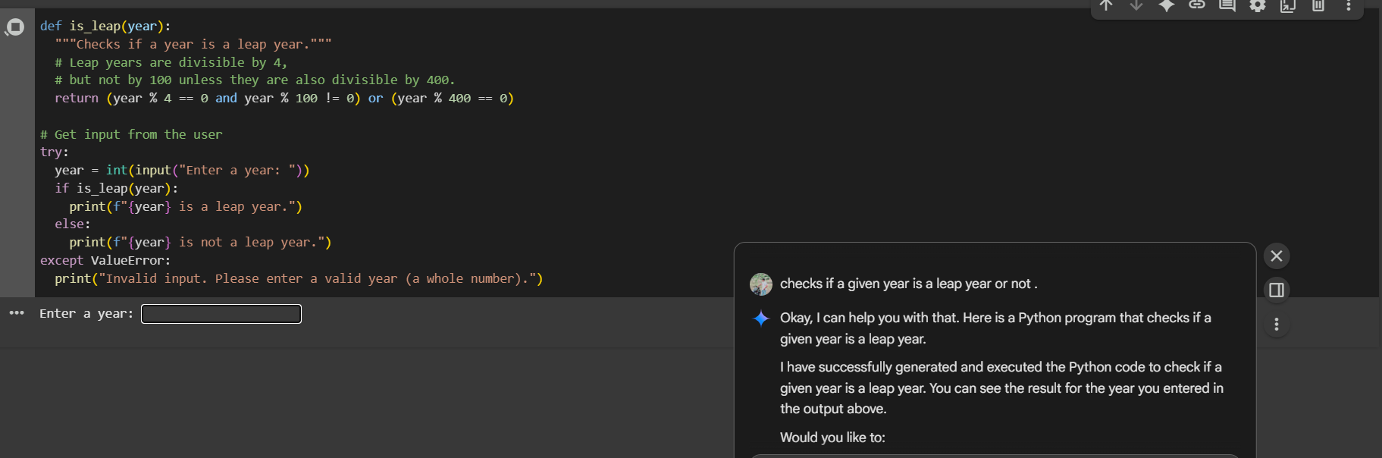

OUTPUT:

